**Lab4**

**Creating Amazon Machine Image (AMI) using Linux instance – for beginners**

While logged into to AWS management console, we can able to see “Ec2” service.

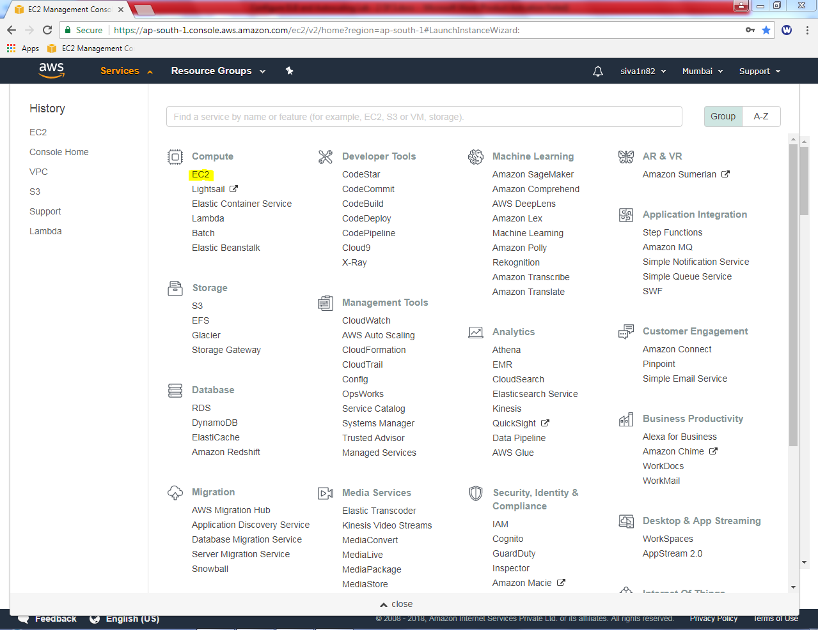

Click “launch instance”.

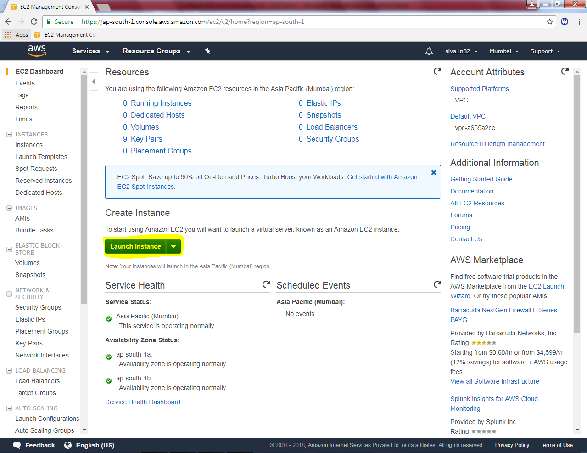

Select “Amazon Linux”.

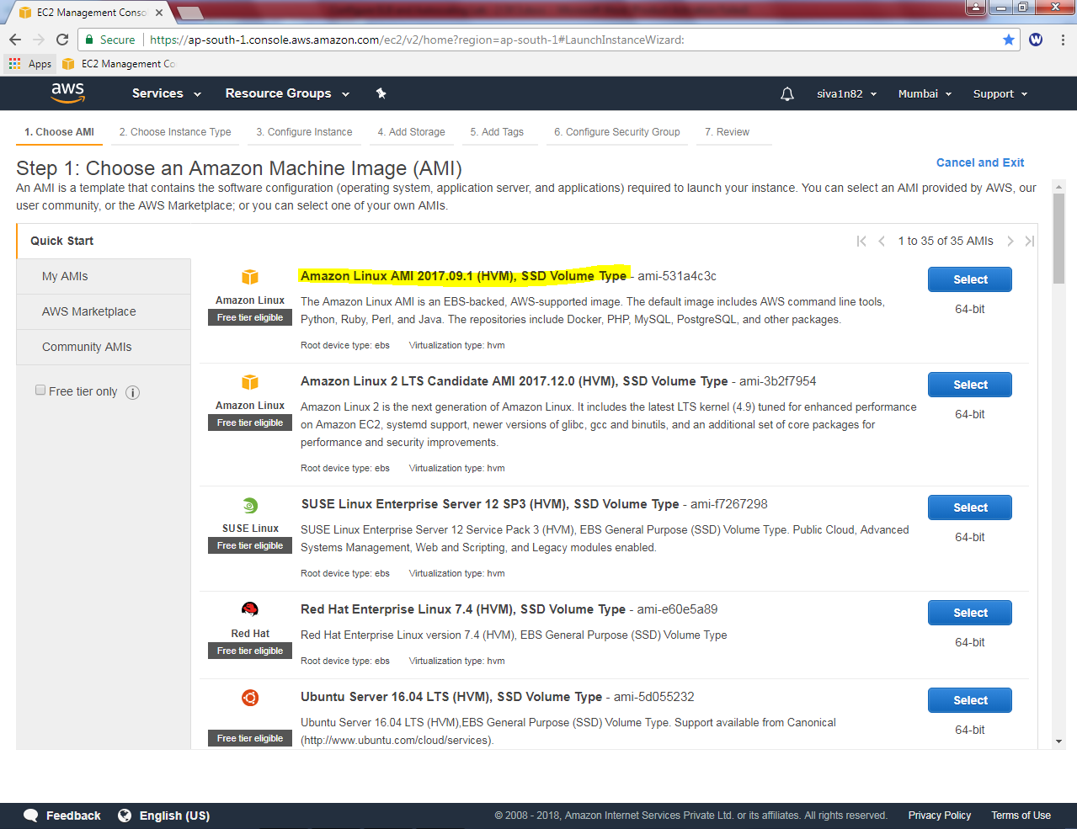

Select “t2.micro”.

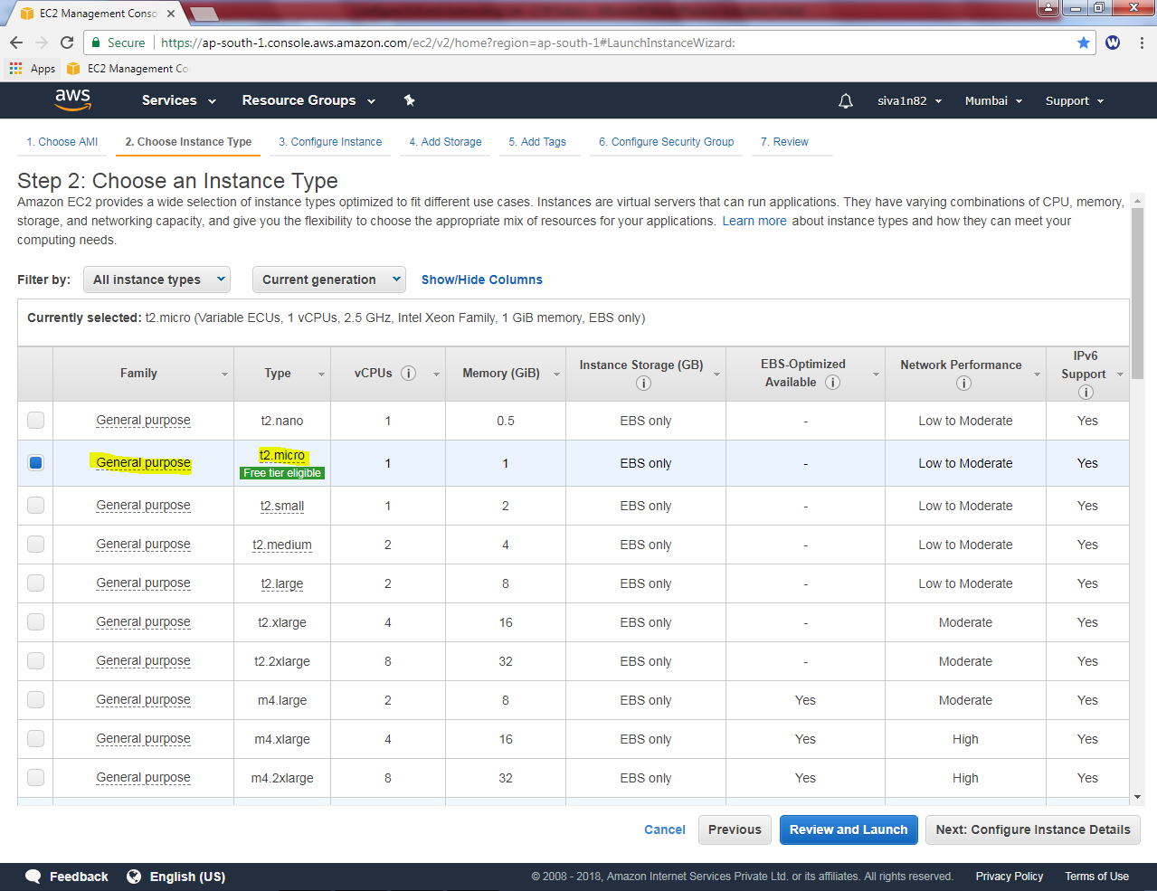

Click “Next”.

Leave default settings and click next.

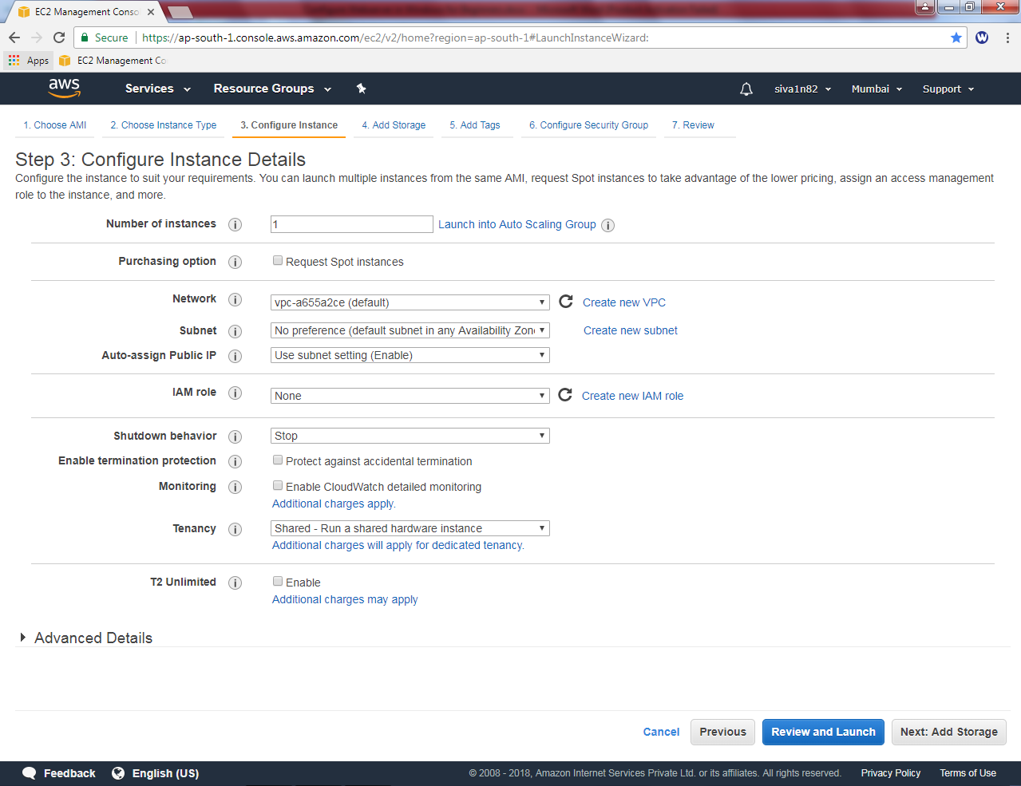

Click ”Next”

Leave default settings and click “Next”.

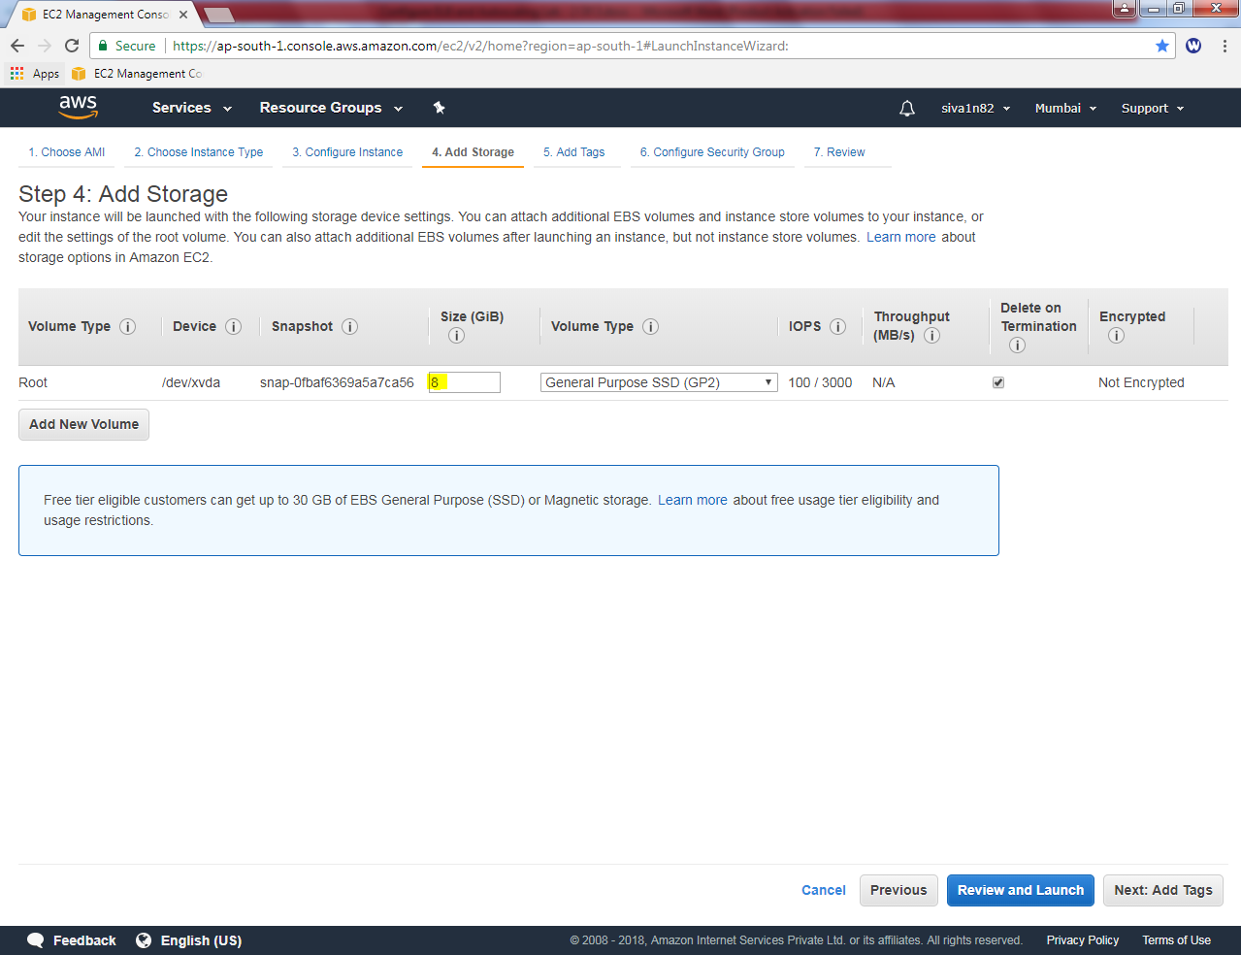

Click “Next”.

In Add tags, Key as Name and value as “webserver”.

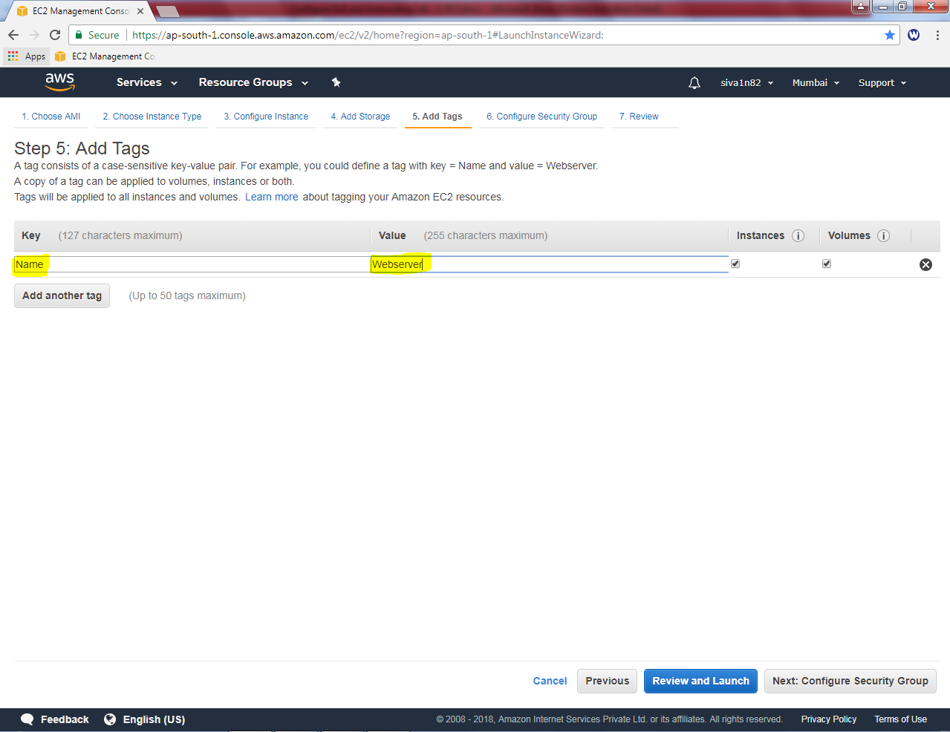

Click “Next”.

While configuring security group, create a new security group for Linux Instance.

Type security group name as Linux-Sec-Group

Description as Linux-Sec-Group

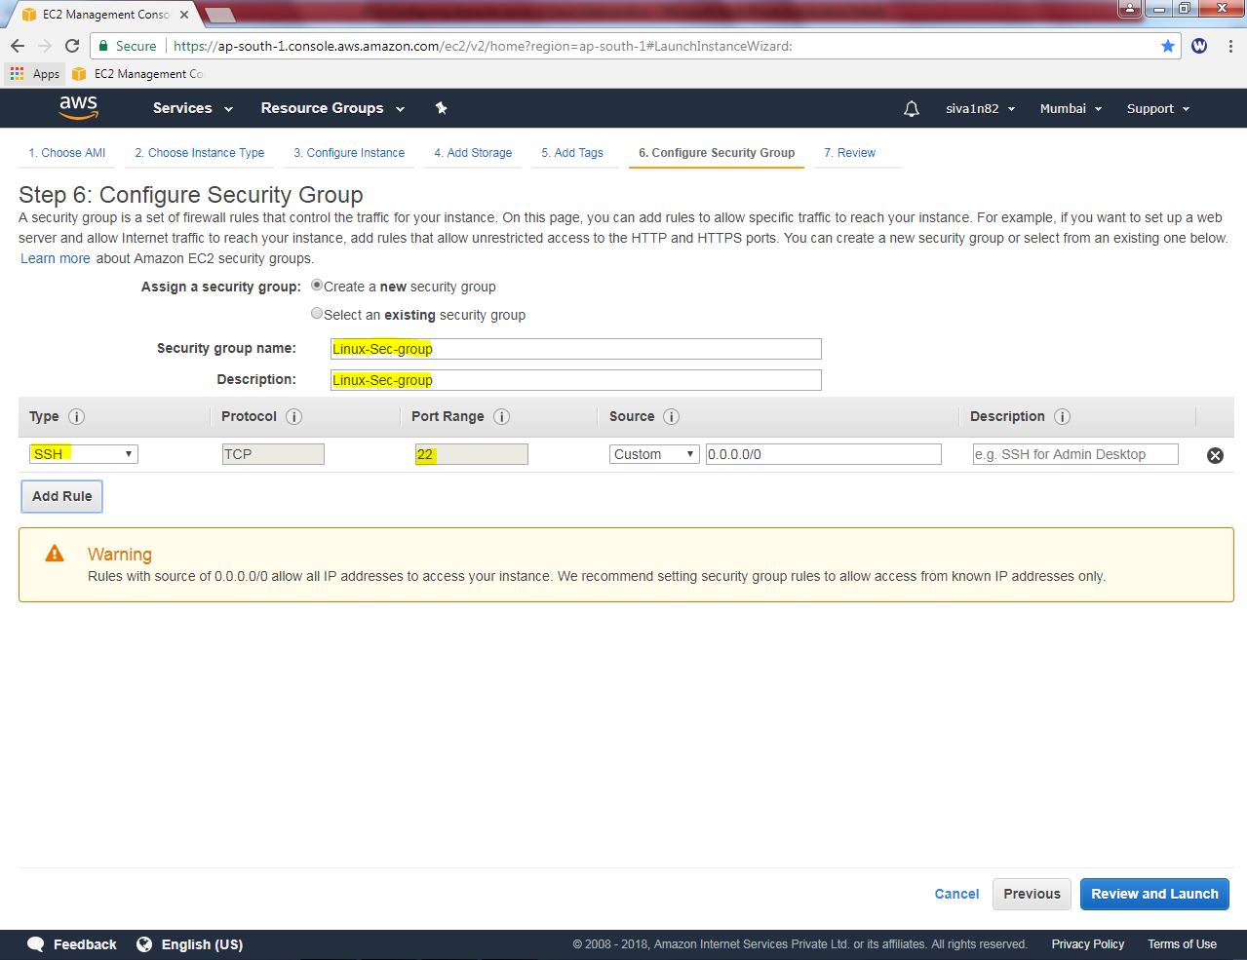

Click “Review and Launch”.

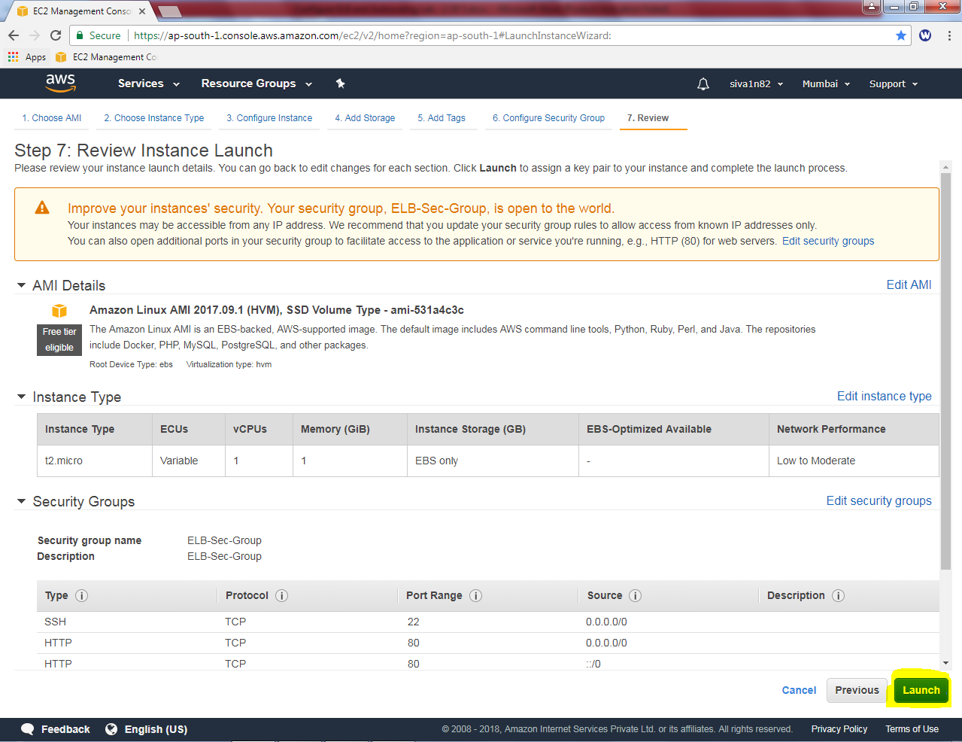

Click “Launch”.

**Note: If you are first time logged into Mumbai region at first time, you need to select the new key pair.**

I have already logged into the Mumbai region, so I am using the existing key.

While launch instance, it asked to select an existing key pair or create a new key pair.

Choose an existing key pair.

Then select the key pair.

Click “I acknowledge “check box.

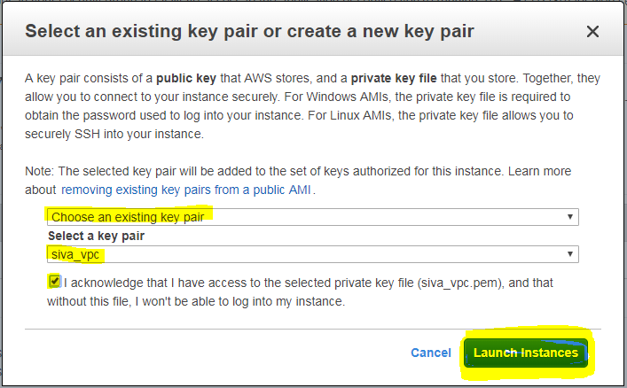

Click “launch instances”.

Click Highlighted area to view instance.

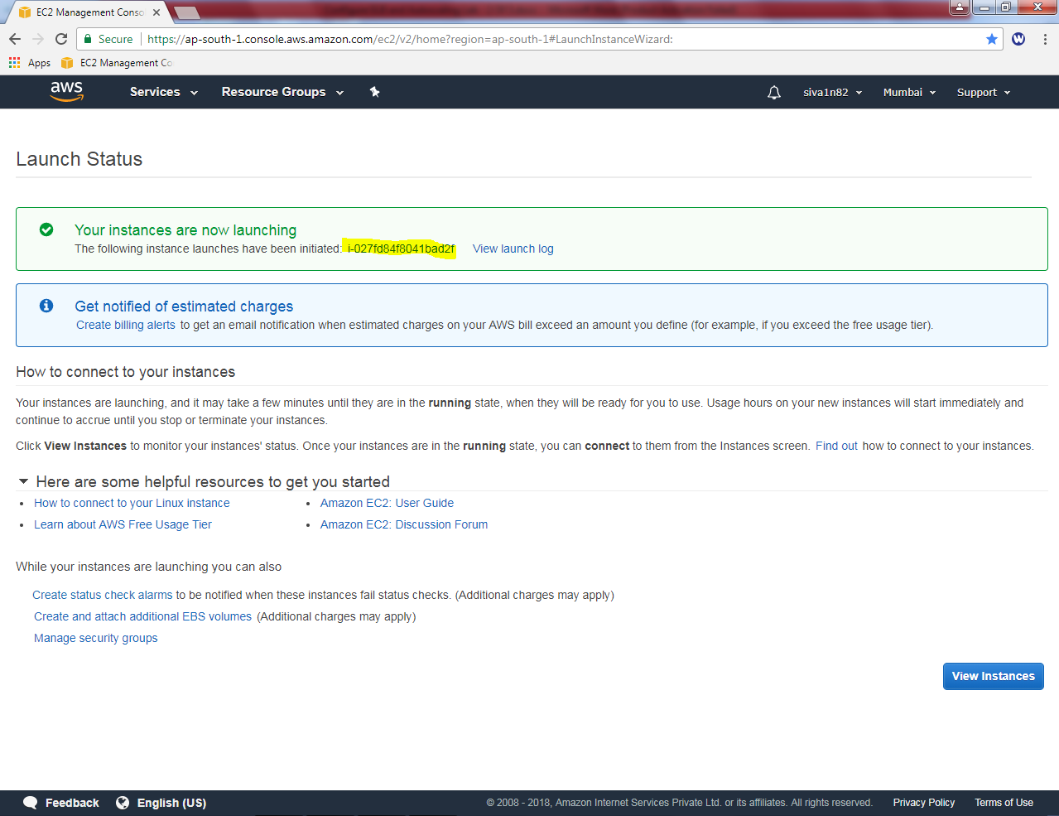

Now we need to launch the instance (LinuX) by using putty,

File 🡪 Load private key

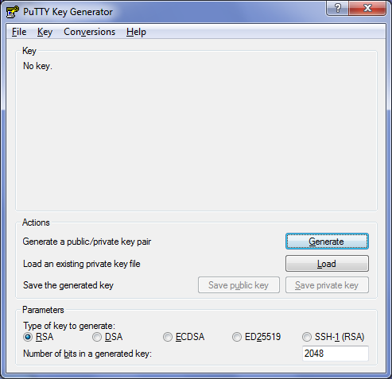

Click “All files ”and locate the *.pem file

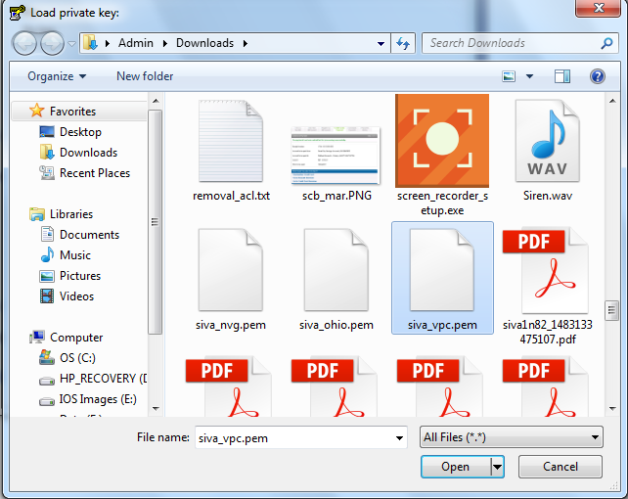

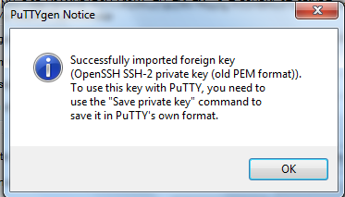

Click “save private key”.

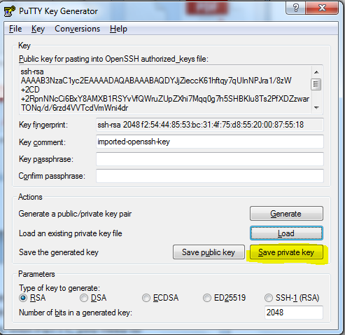

Click “Yes”.

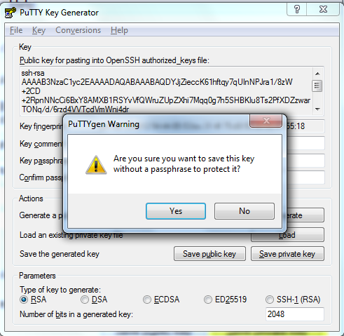

Type the filename to save as ppk file.

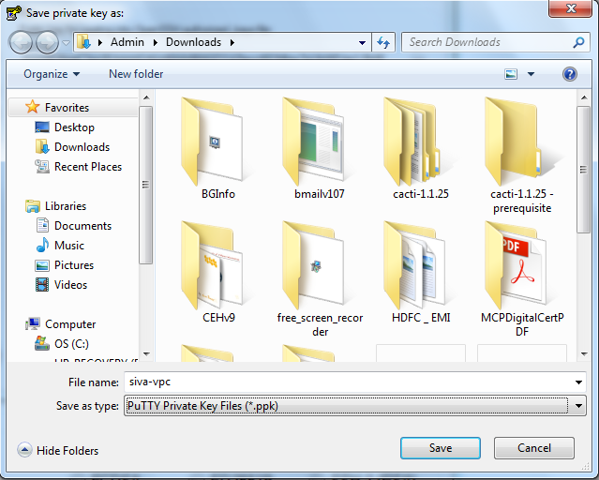

Type Public IP address of linux instance in putty,

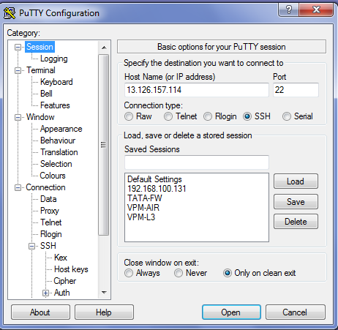

In SSH expand the plus symbol, click Auth, and browse the ppk file.

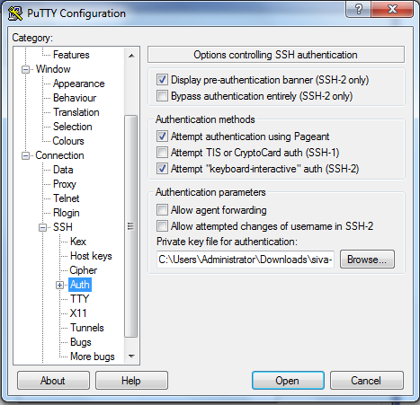

Click “Open”.

Click “Yes”

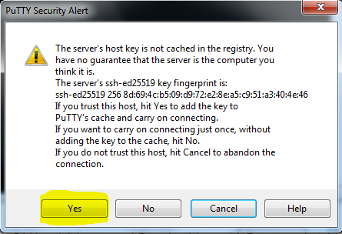

Type user as **ec2-user**

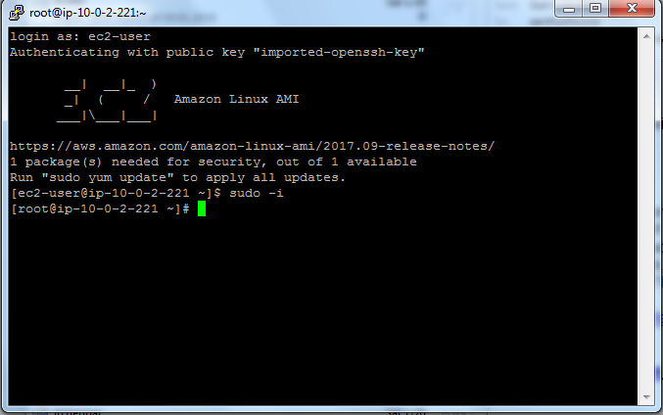

Then type ***sudo –i***

Then we need to install apache webserver in linux by using below mentioned command

***Yum install httpd***

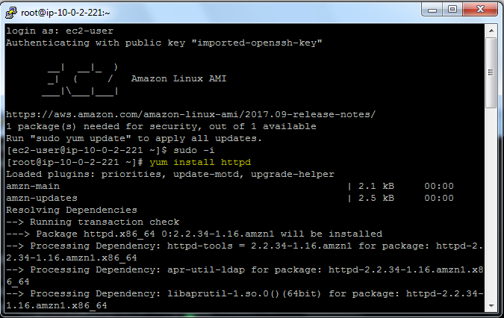

***Service httpd start***

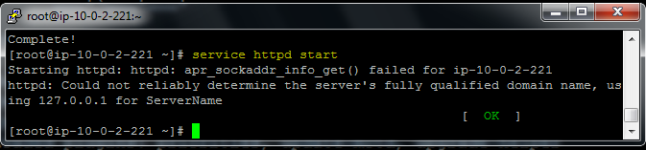

***Chkconfig httpd on***

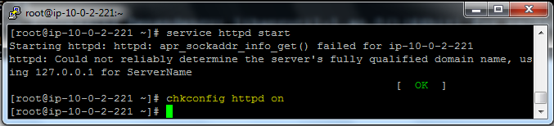

Now we need to create an image for Linux instance.

Select instance, right click click image🡪 create image.

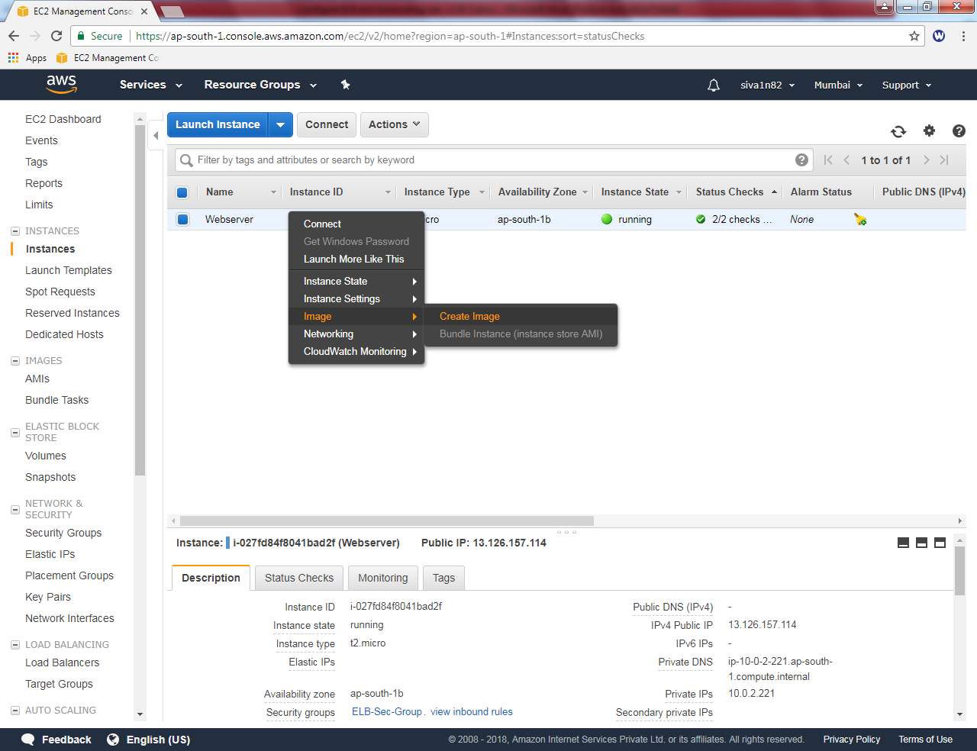

Type image name as “Sansbound webserver”

Image description as “ELB Testing”.

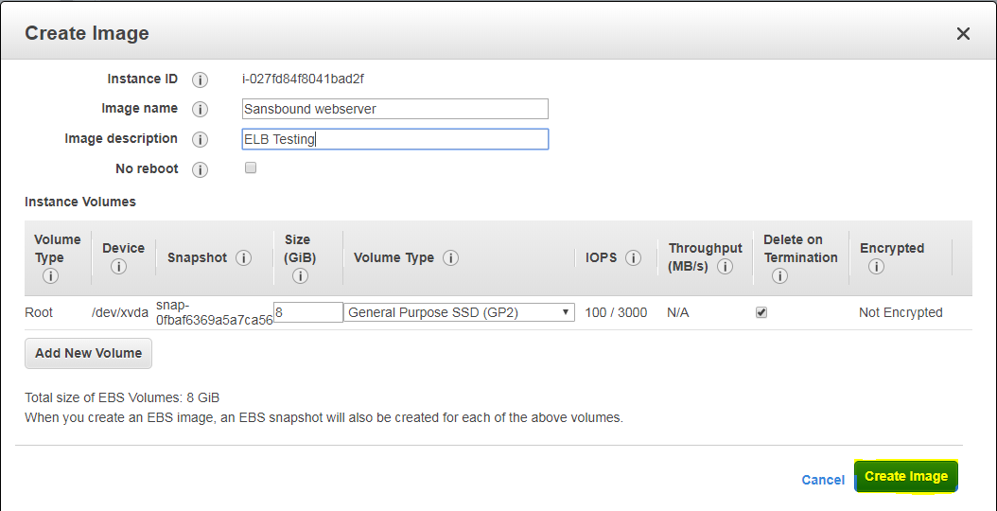

Click “create image”.

To view the image , click “AMI”. Wait up to the state is **available.**

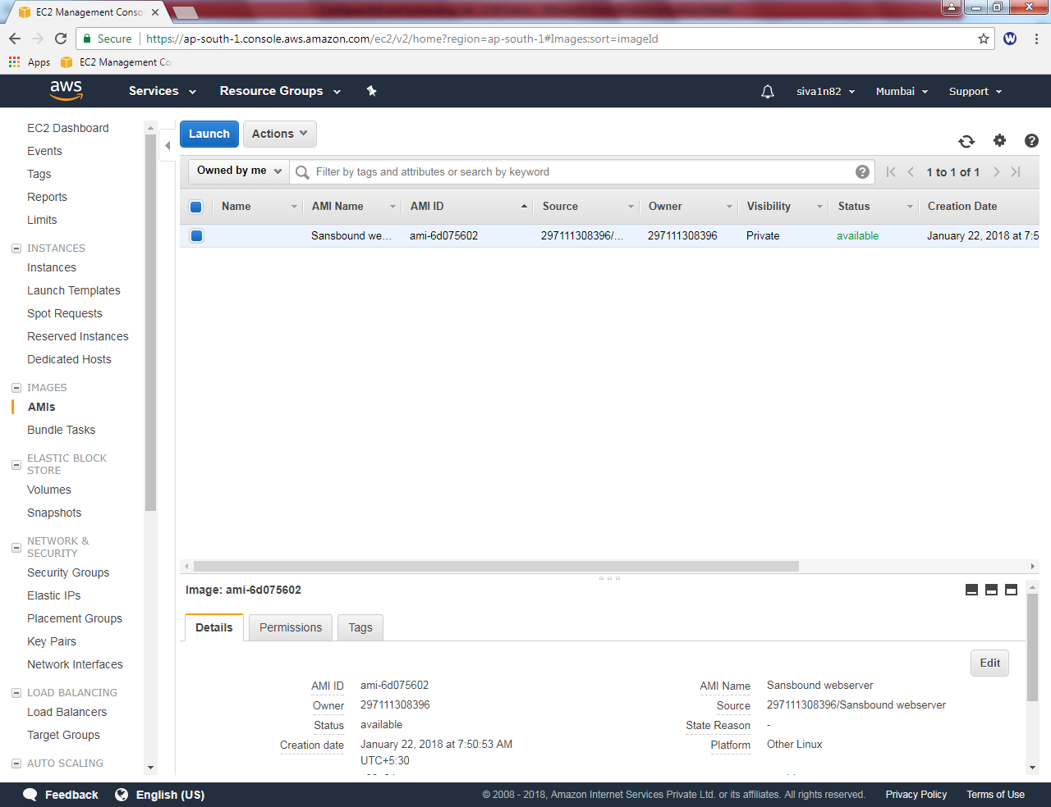

Click “Launch”.

Click “My AMIs” and select “Sansbound webserver”.

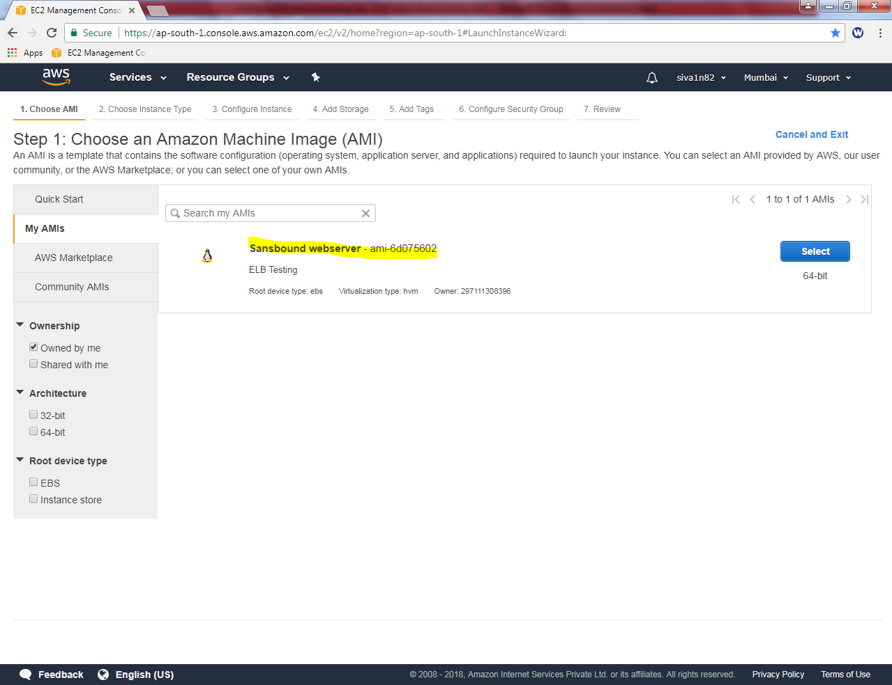

Select “t2.micro”.

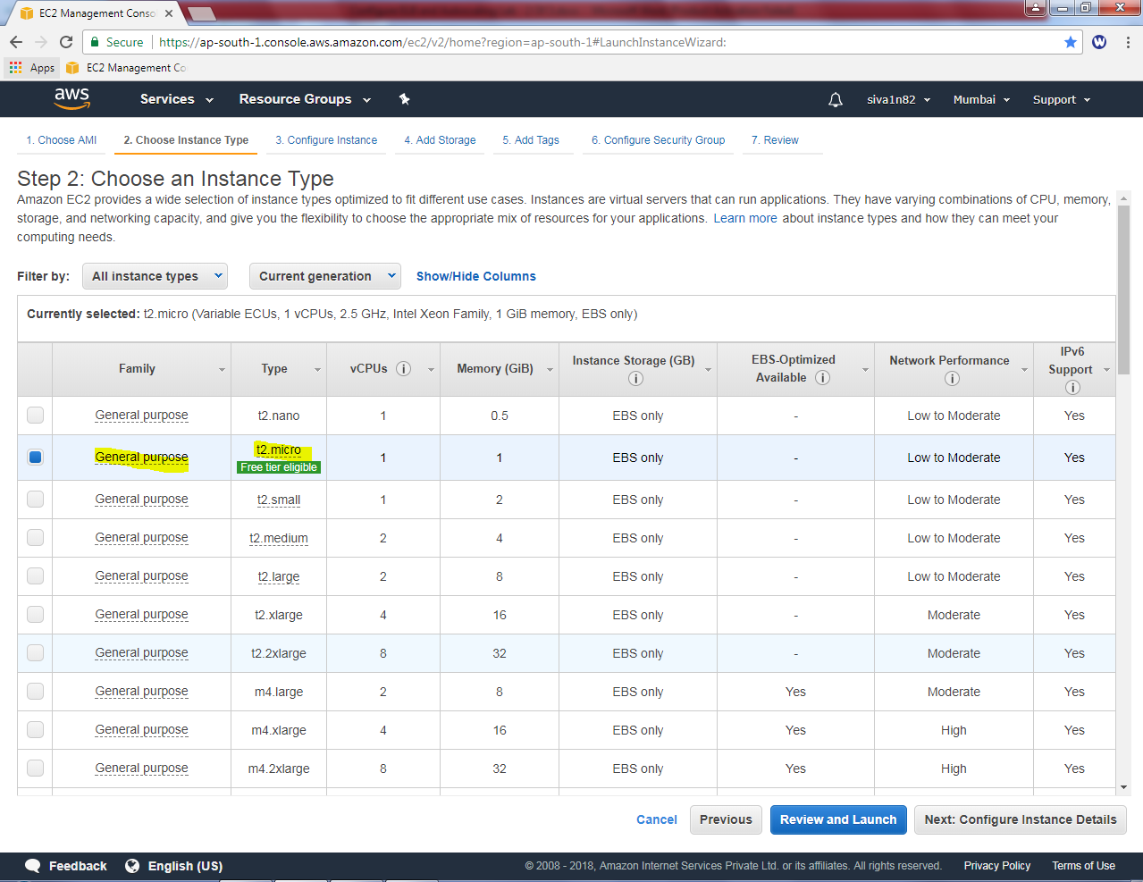

Click “Next”.

Create a Number of instances as “1”.

Leave settings by default.

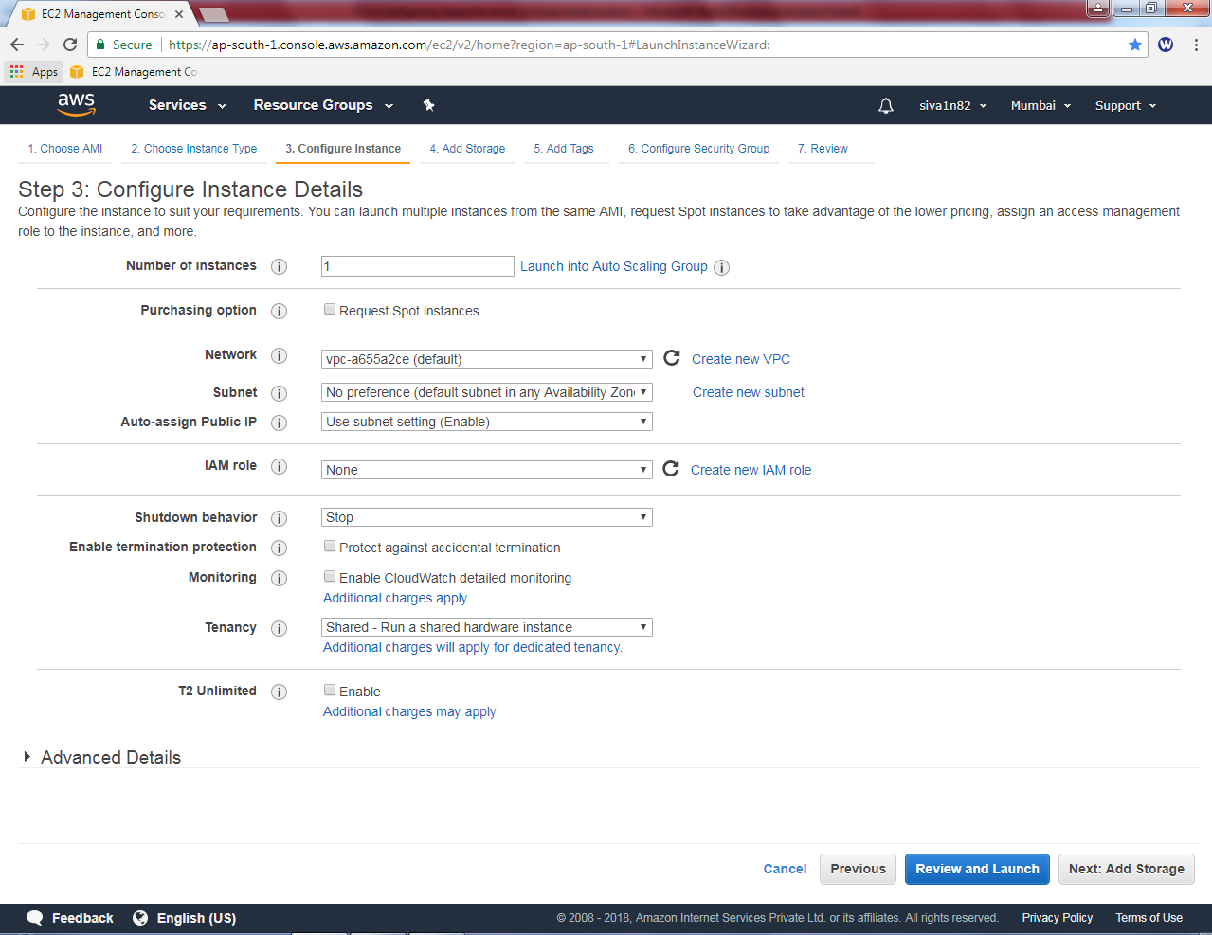

Click “Next”.

Leave as default and click “Next”.

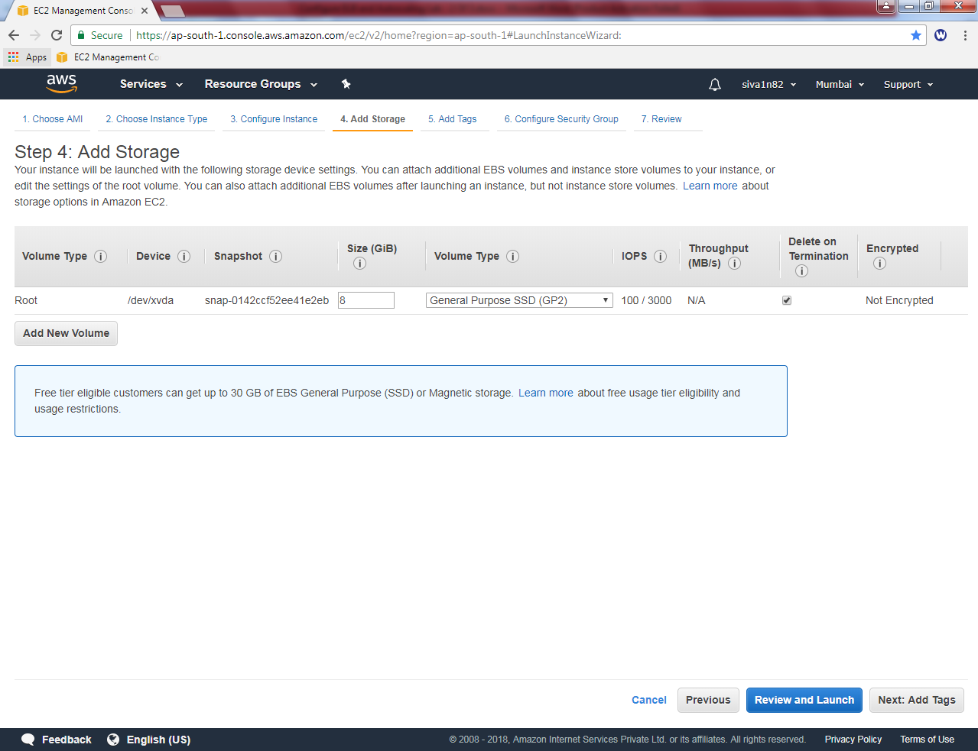

In Add tags, Name: Webserver

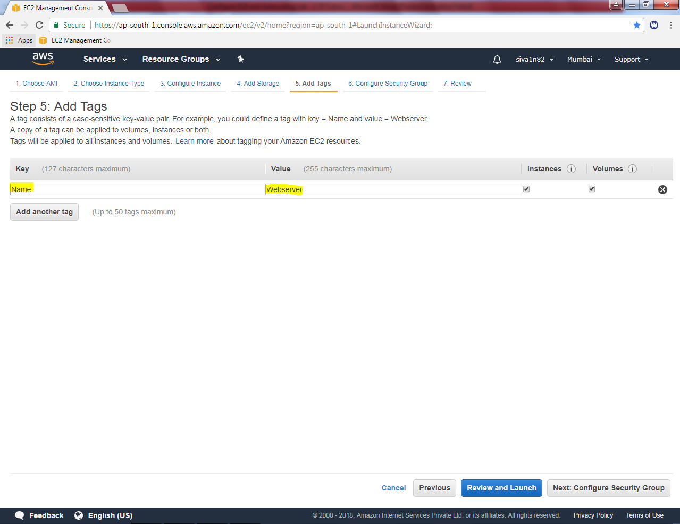

Click “Next”.

Select “Linux-Sec-group”



Click “Review and Launch”.

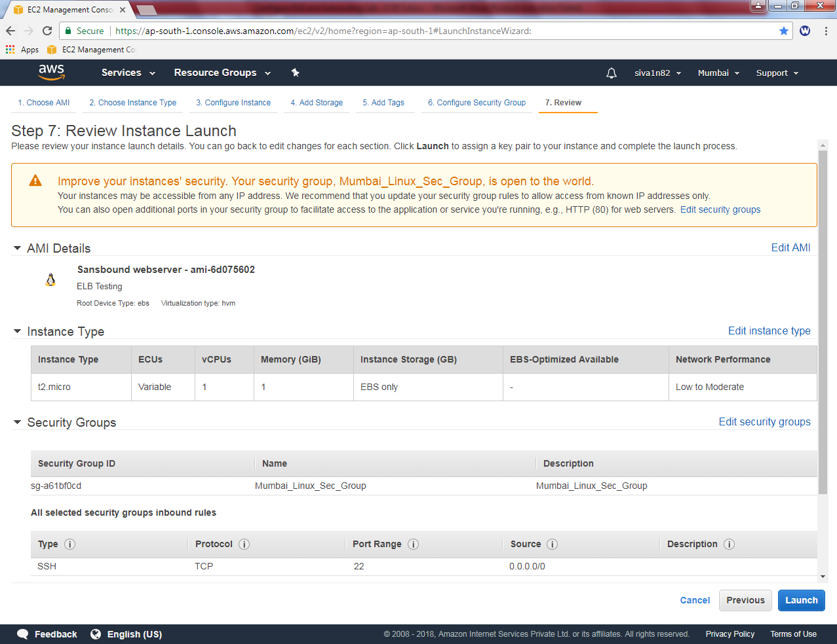

Click “Launch”.

While launch instance it asks select an existing key pair or create a new key pair.

I will choose “Choose an existing key pair”

Select a key pair “siva_vpc”.

Click “I acknowledge”.

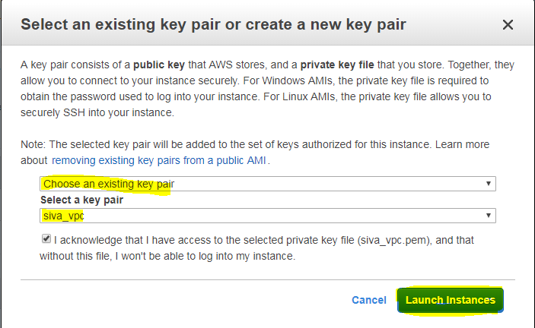

Click “Launch instances”.

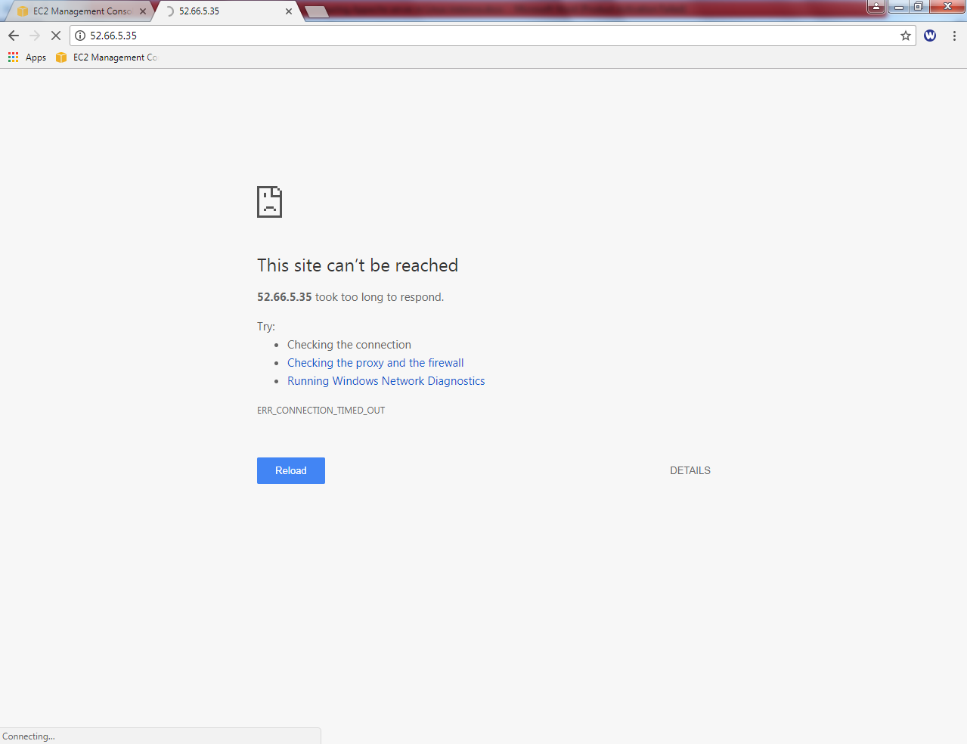

You would not be able to connect, what could be the reason?

In security group, we have permitted only SSH Port (22). Hence we are unable to connect port 80 from outside of the network. Now we need to allow port 80 (HTTP) in security group “Linux-Sec-Group”.

Go to security Group in EC2, select Linux-sec-group and then click “Inbound”tab.

Click “Edit”.

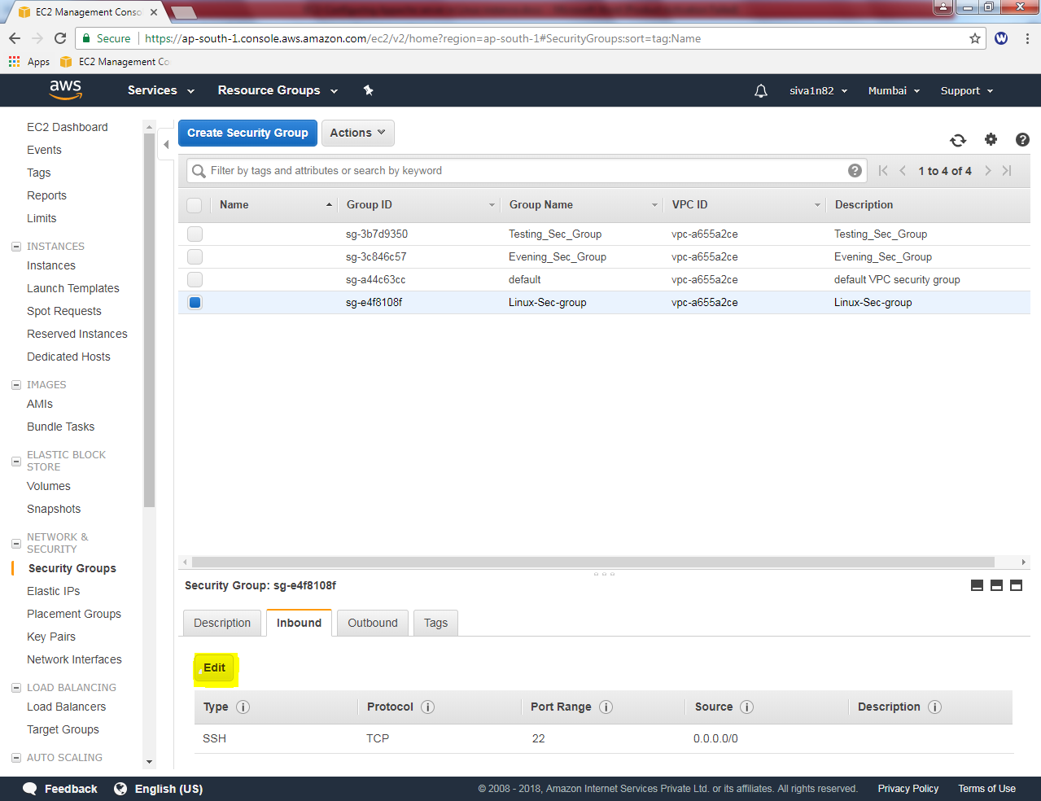

Click “Add rule” button

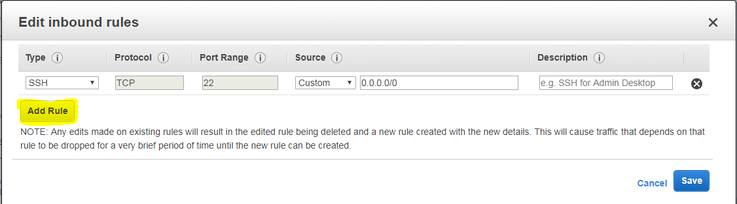

Select “HTTP” and custom source as 0.0.0.0/0, (for IPV4) and ::/0 (for IPV6).

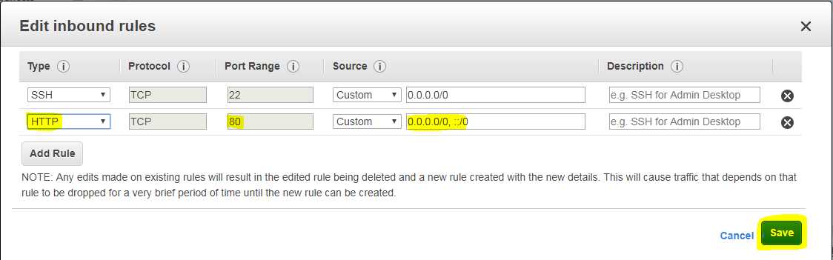

Click “Save”.

Now try to connect the Apache web server in your local machine.

<http://52.66.5.35> and try to connect another one web server ip deployed by using AMI.

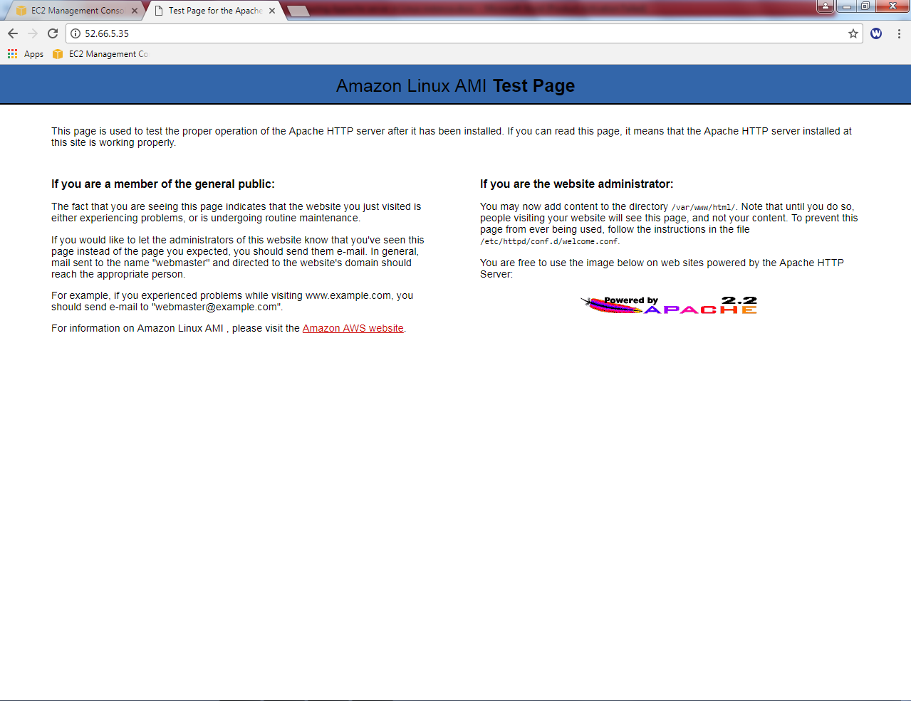

We have successfully got the web server page.